Finance – SQL Logical Tests
- Price — should be between 52w low/high when they both exist
SELECT
COUNTIF(WeekLow52 IS NOT NULL AND WeekHigh52 IS NOT NULL
AND (price < WeekLow52 OR price > WeekHigh52)) AS price_outside_52w,
COUNTIF(WeekLow52 IS NOT NULL AND WeekHigh52 IS NOT NULL
AND WeekLow52 > WeekHigh52) AS inverted_52w_range
FROM `projectspractice12.sp500dataAnalysis.sp500data`;

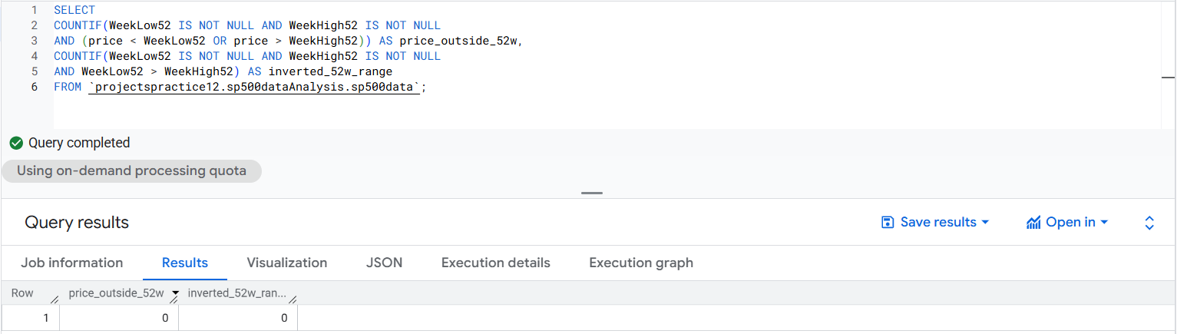

- (P/E — price / EPS) ≈ reported P/E (less than 2)
SELECT
COUNT(*) AS rows_checked,
COUNTIF(ABS((price / NULLIF(EarningPerShare,0)) - priceToEarnings) > 2) AS pe_mismatch_gt2
FROM `projectspractice12.sp500dataAnalysis.sp500data`;

